SWE40002 Software Engineering Project B

Semester 2, 2023

Learning Summary Report

Name: Tay Chia Haw

Student ID: 101214446

Team Eric: 13

Project Name: Digital Document Management (DDM)

## Introduction

This document aims to communicate my outcome for the unit SWE40002 Software Engineering Project A. This document has been structured to include self-assessment details to support the grade outcome I believe I have attained, a summary list of specific significant supporting evidence, including an analysis of my activities, a details presentation of the alignment between the evidence details with the learning outcomes, and a personal reflection on the overall learning and results.

## Self Assessment

As a team member, I was required to participate in every group discussion and meeting as a team member in order to contribute to the team's conclusions and decision-making. I had to contribute to the written reports produced by the team and make myself available to any team member who might need support. I must also finish the assignments on schedule while producing high-quality reports.

For this unit, I am aiming for a grade of Pass. To get the desired grade, I must prove that I can complete tasks on high with high-quality work, which the lecturer and client could also consider as high work quality. I should be initiative and responsive in team discussions and meetings.

I believe that the team and I interact with each other well. I agreed with the group throughout meetings, discussions, and work assignments. However, I am conscious that my ineffective time management has slowed down my performance. I frequently need help to finish projects, which has slowed my job progress. Planning and organizing my time wisely to assist me in understanding the tasks allocated to me and their due dates would be one way to address this. Also, seeking advice and support from other team members or conducting additional research online may be helpful.

## List of Contributions

List of contributions:

|  |  |  |  |
| --- | --- | --- | --- |
| No. | Task | Path | Hour(s) Spent |
|  | Project Proposal Report (Project Objectives) | Page 2 | 0.5 |
|  | Project Proposal Report (Project Outputs) | Page 2 | 0.5 |
|  | Project Plan Report (Project Objectives) | Page 2 | 0.5 |
|  | Project Plan Report (Anticipated Outputs and Outcomes) | Page 2 | 0.5 |
|  | Project Plan Report (Overall Approach) | Page 3 | 0.5 |
|  | Project Plan Report (Anticipated Impact ) | Page 4 | 0.5 |
|  | Project Plan Report (Stakeholder Analysis) | Page 4 | 0.5 |
|  | Project Plan Report (Related Projects) | Page 5 | 0.5 |
|  | Project Plan Report (Constraints) | Page 5 | 0.5 |
|  | Project Plan Report (Assumptions) | Page 6 | 0.5 |
|  | Project Plan Report (Risk Analysis) | Page 6 | 0.5 |
|  | Project Plan Report (Technical Development) | Page 8 | 0.5 |
|  | Project Plan Report (Standards) | Page 8 | 0.5 |
|  | Project Plan Report (Intellectual Property Rights ) | Page 9 | 0.5 |
|  | Project Plan Report (Project Roles) | Page 11 | 0.5 |
|  | Project Plan Report (Evaluation Plan) | Page 12 | 0.5 |
|  | Project Plan Report (Quality Assurance) | Page 13 | 0.5 |
|  | Project Plan Report (Dissemination Plan) | Page 14 | 0.5 |
|  | Project Plan Report (Exit and Embedding Plans) | Page 15 | 0.5 |
|  | Project Plan Report (Sustainability Plans) | Page 15 | 0.5 |
|  | SRS Report (Definitions, Acronyms and Abbreviations) | Page 5 | 0.5 |
|  | SRS Report (Business Rules) | Page 6 | 0.5 |
|  | SRS Report (Product Perspective) | Page 7 | 0.5 |
|  | SRS Report (User Classes and Characteristics) | Page 7 | 0.5 |
|  | SRS Report (User Documentation) | Page 8 | 0.5 |
|  | SRS Report (Assumptions and Dependencies ) | Page 9 | 0.5 |
|  | SRS Report (User Interfaces) | Page 17 | 0.5 |
|  | SRS Report (Software Interfaces) | Page 18 | 0.5 |
|  | SRS Report (Communications Interfaces) | Page 18 | 0.5 |
|  | SRS Report (Usability) | Page 18 | 0.5 |
|  | SRS Report (Reliability) | Page 19 | 0.5 |
|  | SRS Report (Security) | Page 19 | 0.5 |
|  | SRS Report (Availability) | Page 19 | 0.5 |
|  | SRS Report (Performance) | Page 19 | 0.5 |
|  | SRS Report (Maintainability) | Page 20 | 0.5 |
|  | SRS Report (Change Management Process) | Page 20 | 0.5 |
|  | Register account | Register page | 2 |
|  | Login account | Login page | 2 |
|  | Localization Module | Navigation bar | 4 |
|  | Dashboard | Home page | 1 |
|  | User Management Module | At sidebar Maintenance item menu | 3 |
|  | Employee Form | At sidebar Maintenance item menu | 2 |
|  | Employee Form Viewer | At sidebar Page View item menu | 2 |
|  | Change Password Feature | At above of logout button | 2 |
|  | Send password reset link to email | Mail.php | 4 |
|  | Feature Restrict number of Administrator user | RegisterController.php & User Management Module | 2 |
|  | Report Generate module in pdf format | At sidebar Page View item menu | 3 |
|  | Update dashboard features | Home.blade.php | 4 |
|  | Add Profile page | At sidebar Personal Information item menu | 1 |
|  | Strong Password Policy Function | Register page | 2 |
|  | User Feedback Module | At sidebar Maintenance item menu | 2 |
|  | Report Generate module in excel format | At sidebar Page View item menu | 4 |

## Learning Outcome Assessment

* 1. **Product**

*[P] “Contributed adequately to the product. Overall, the team must have produced at least a semi-functional product that meets part of the client requirements.”*

*[C] “Contributed strongly and consistently to the product over the duration of the project. Overall, the team must have produced a solid functional product that meets significant client requirements, using good design standards and practices.”*

*[D] “Contributed significantly, consistently and of a high standard, to the product over the duration of the project.”*

## Screenshots of evidence:

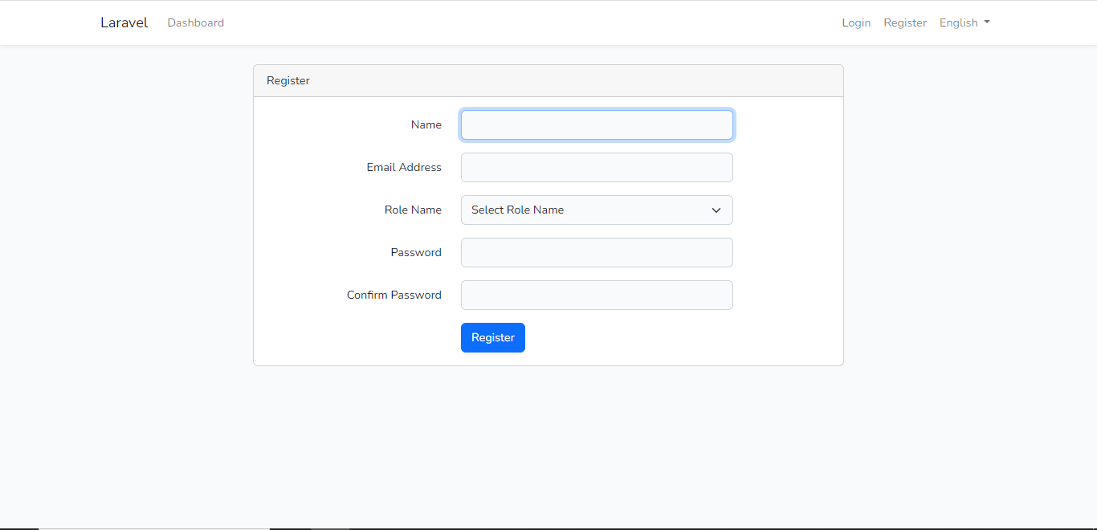

Register page

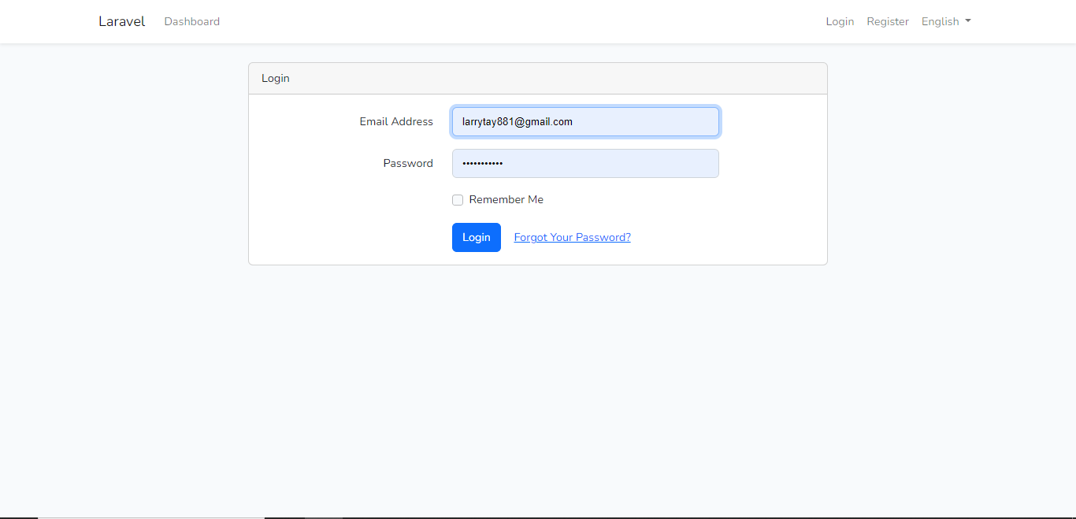

Login page

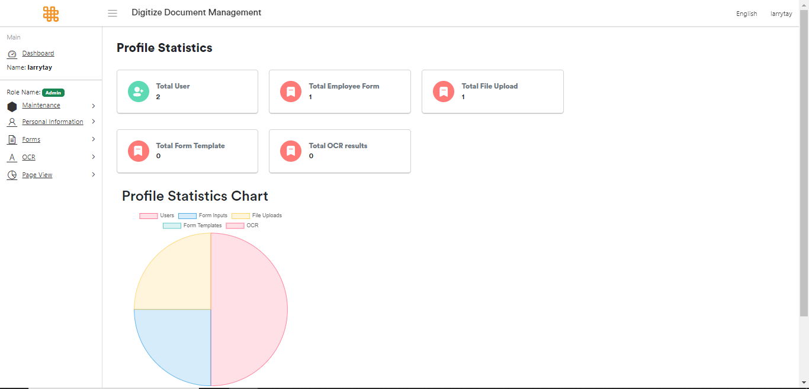

Dashboard in English language

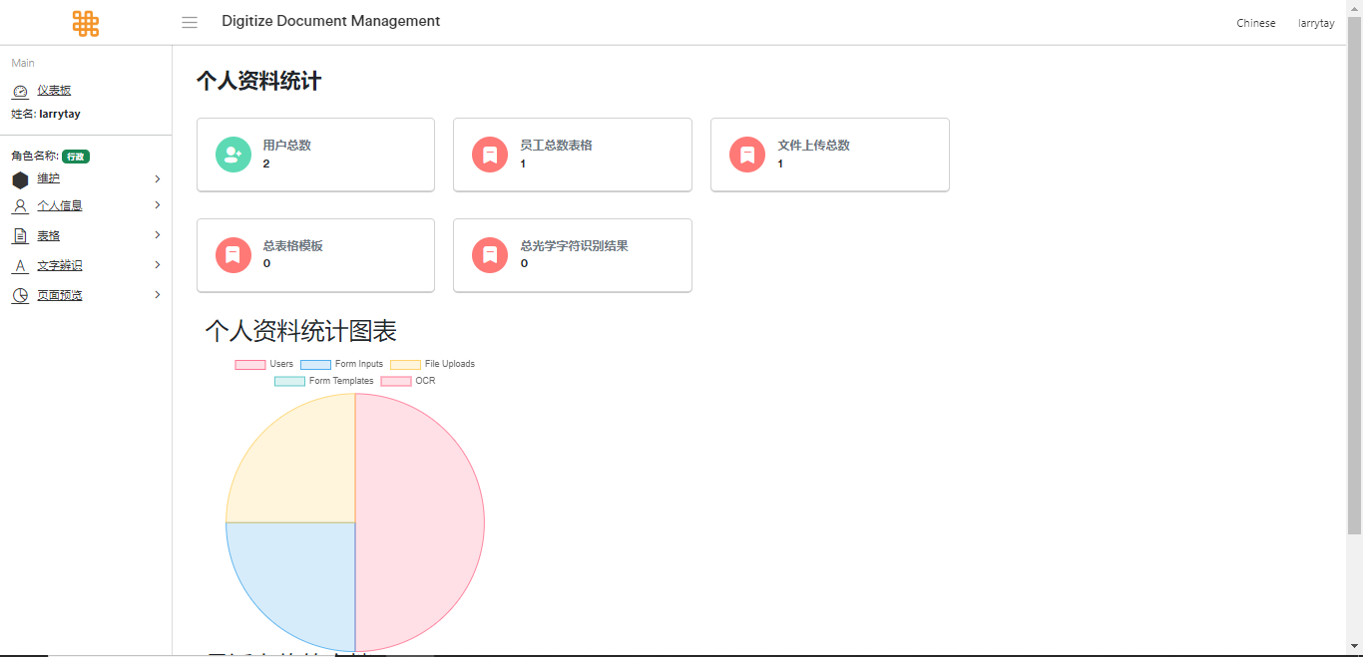

Dashboard in Chinese language

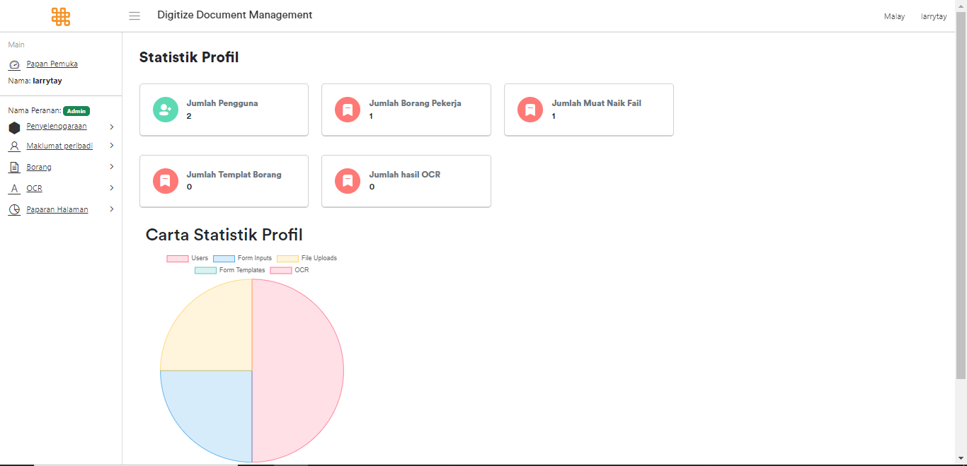

Dashboard in Bahasa Melayu language

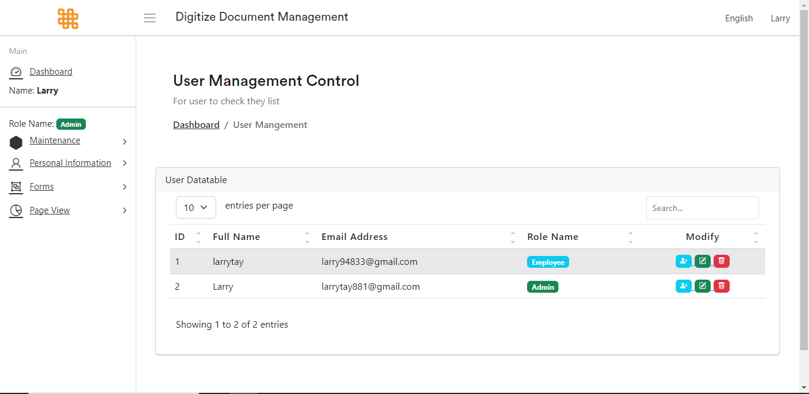

User Management Module

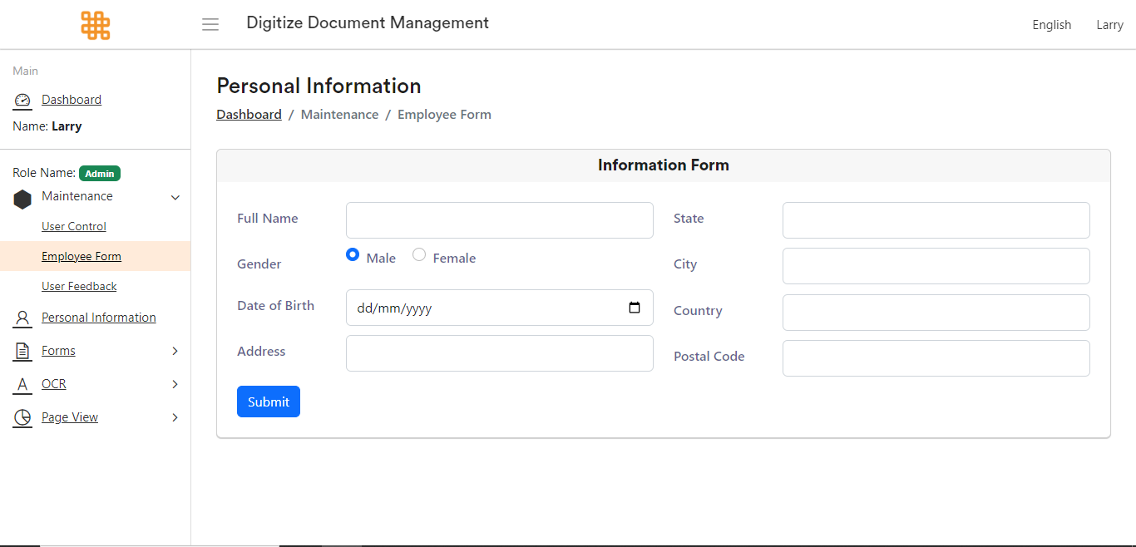

Employee Form

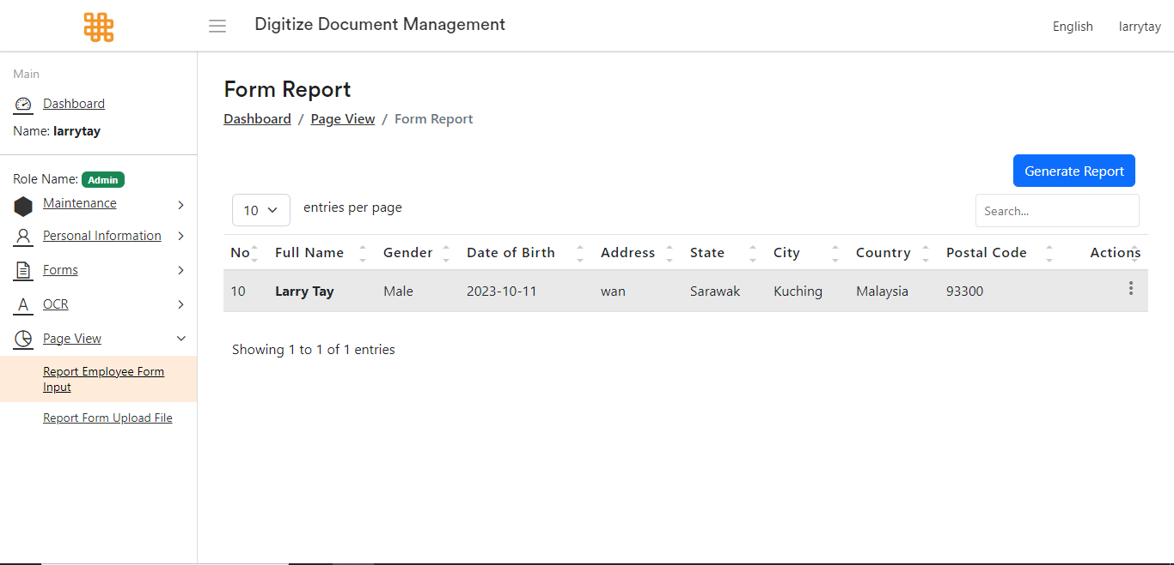

Employee Form Viewer with report generate module

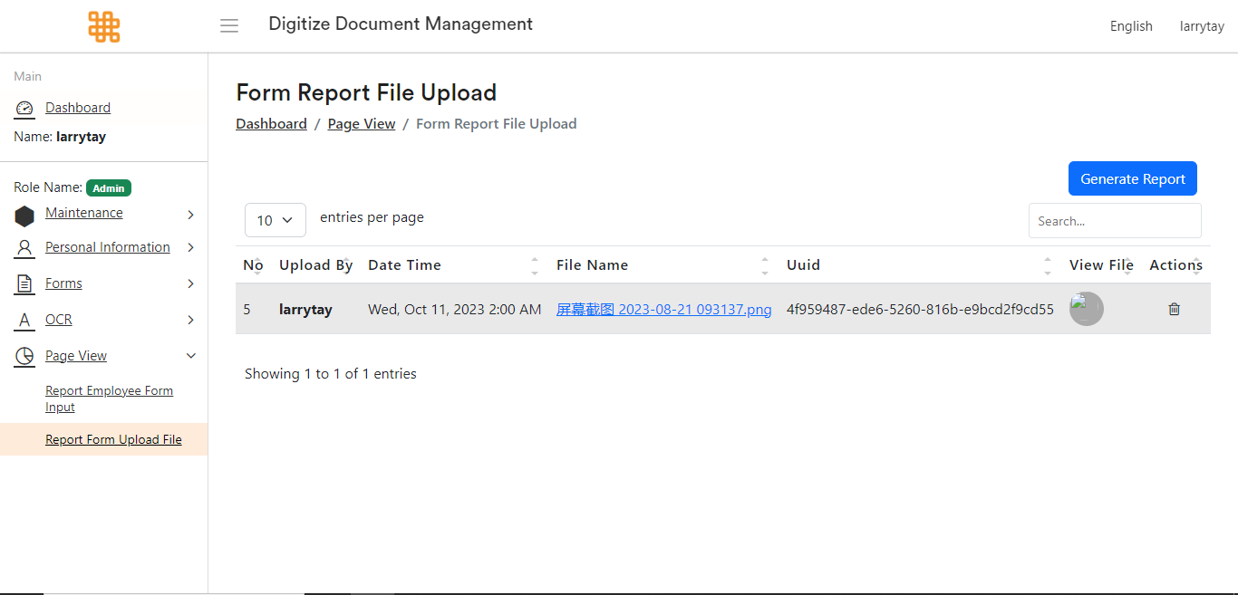

File upload viewer with report generate module

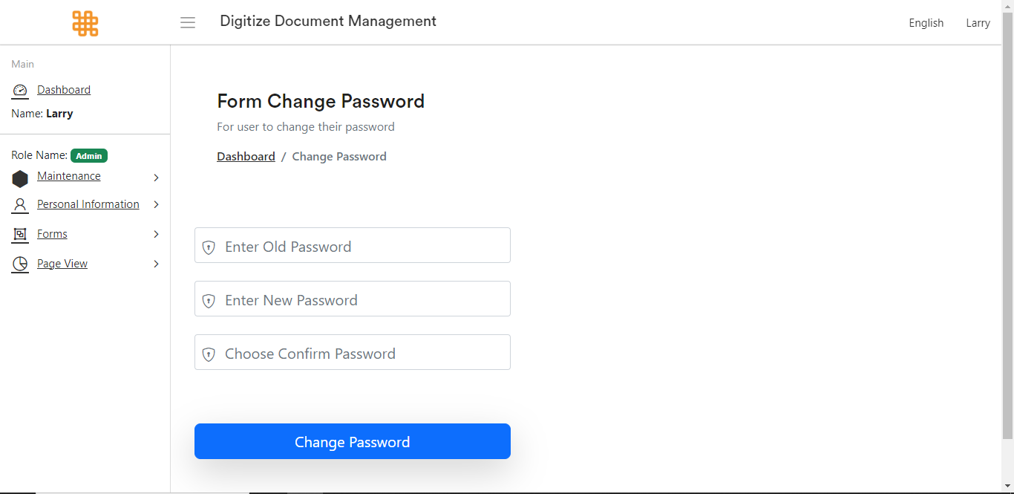

Change Password Page

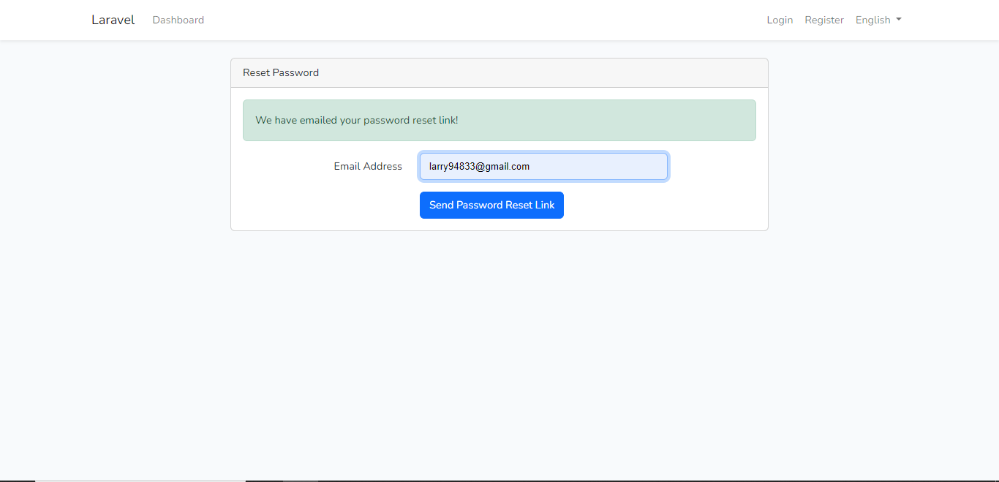

Send password reset link page

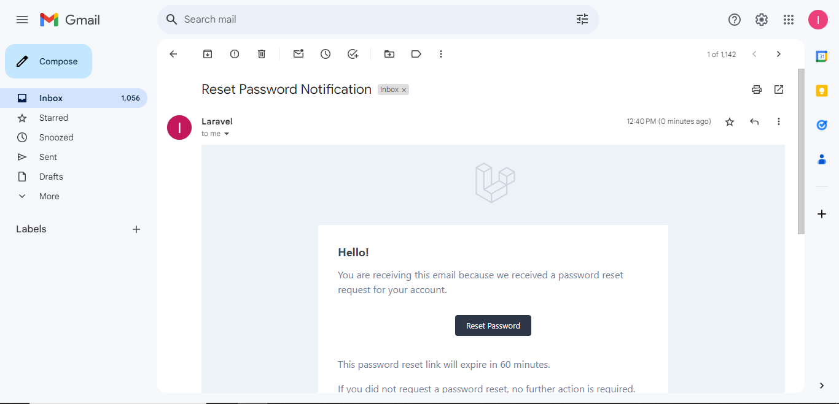

Email received password reset link

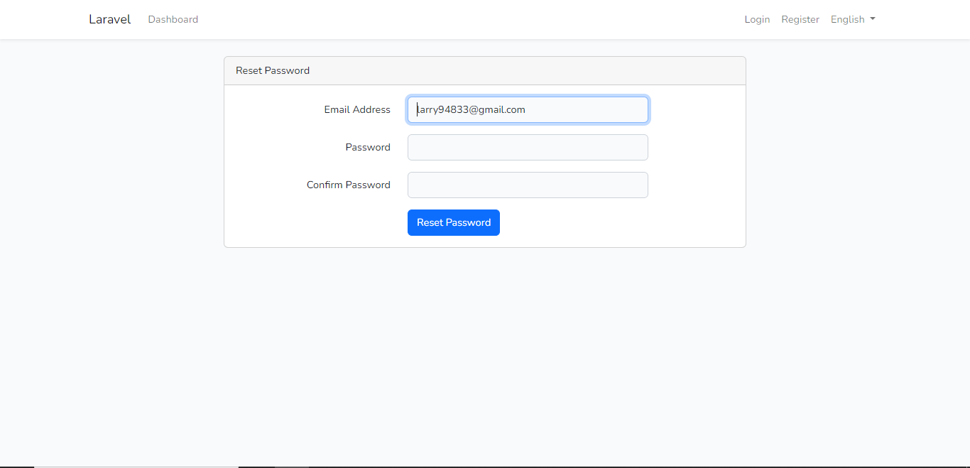

Reset password page after clicked password reset link

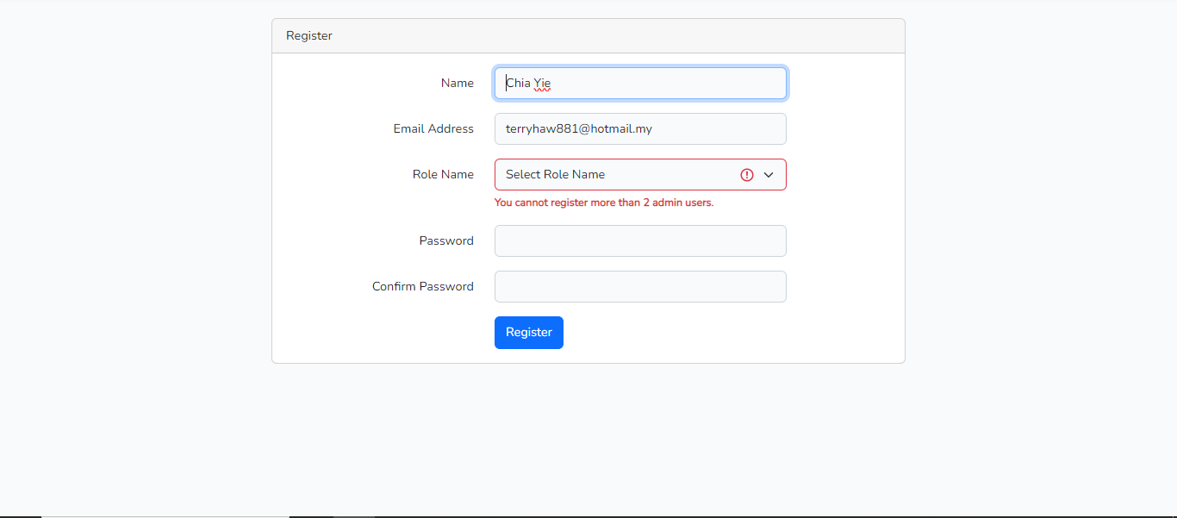  
Register page which restrict user create more than 2 admin user

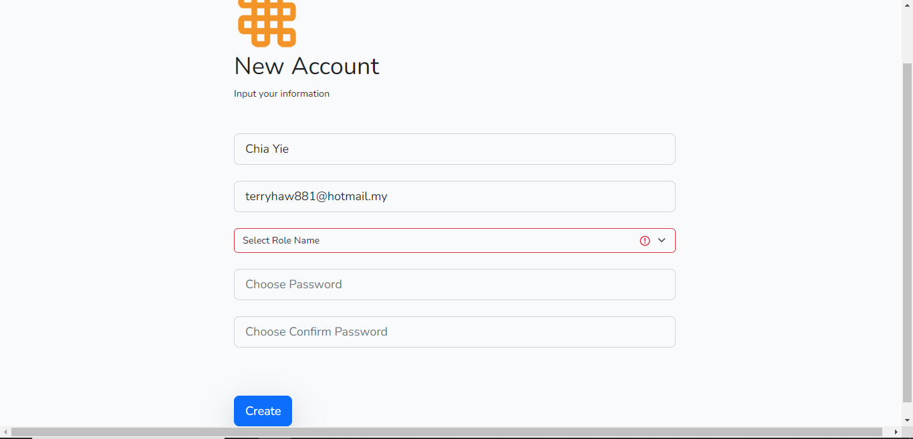  
User Management page which restrict user create more than 2 admin user

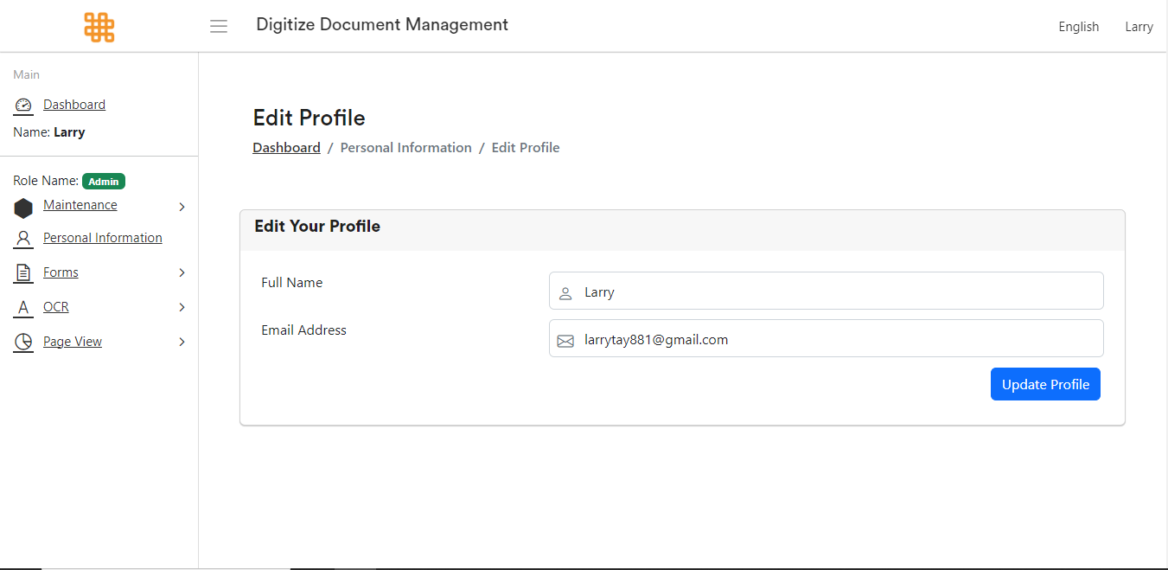

Edit Profile page

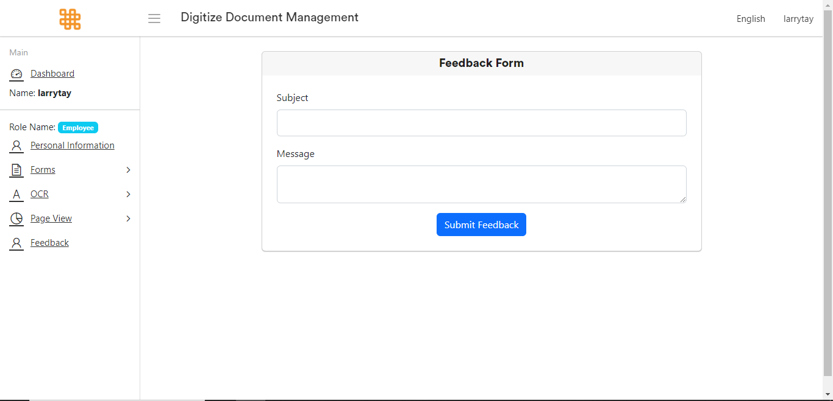

Feedback Form

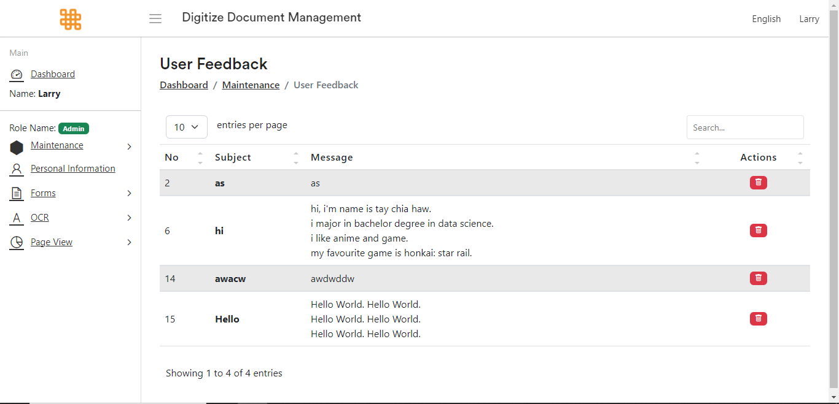

User Feedback Page

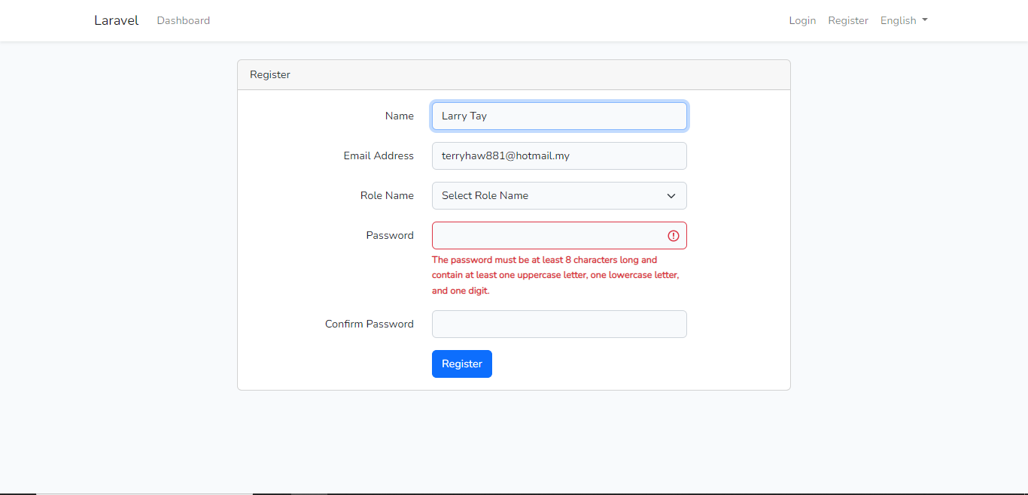

Strong password policy function in Register page

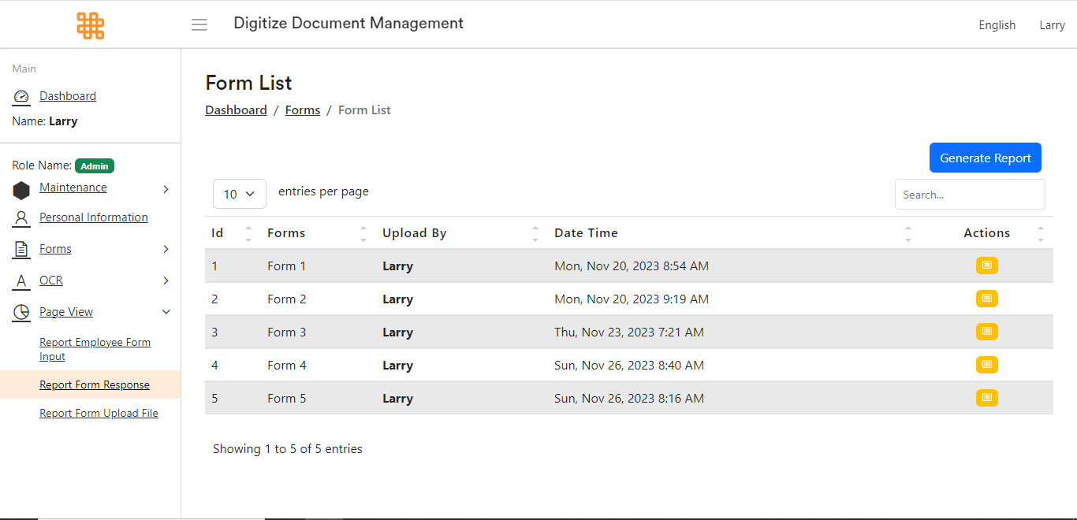

Form Template List with report generate module

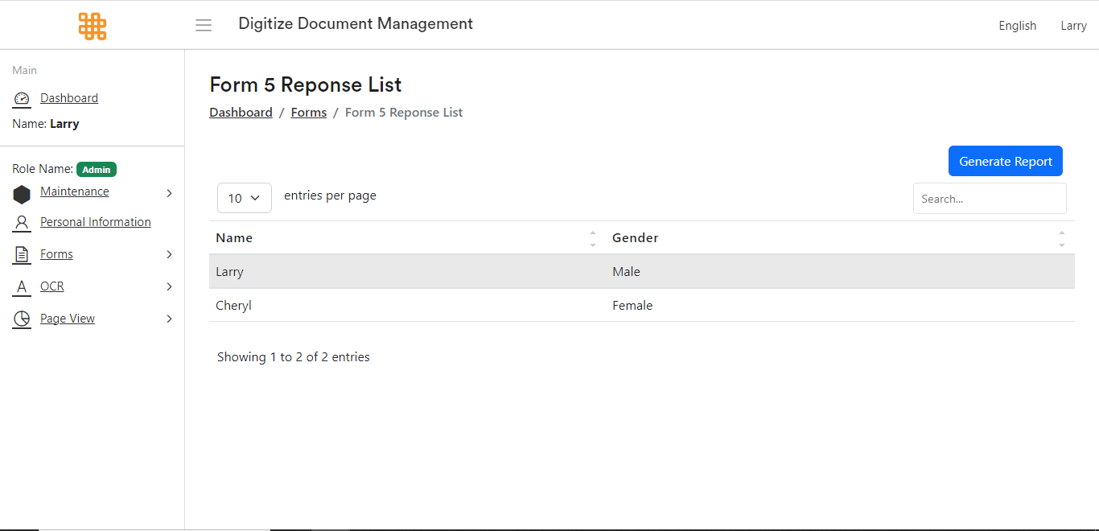

Form Response List with report generate module

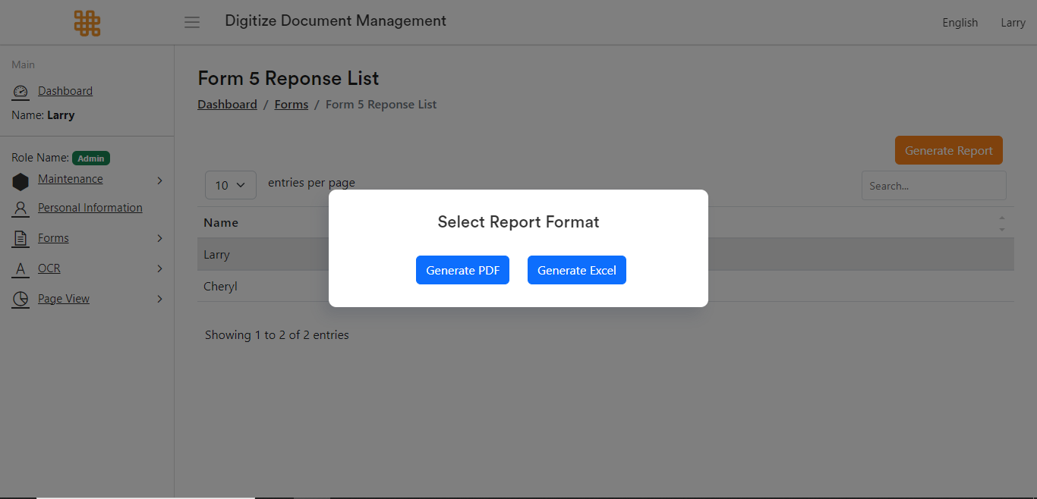

Report Generate Module with PDF and Excel format

|  |  |  |  |
| --- | --- | --- | --- |
| Contribution | Description | Estimated % of the total product | Which client requirements does each address? |
| Project Proposal | A detailed description of the purpose of the project and what the team plans to achieve by the end of the project | 10 | Research and Analysis |
| Project Plan | Detailed description the series of tasks and milestones required to successfully develop, test, and deploy the proposed document digitization system. | 1 | Research and Analysis |
| SRS | Detailed description the requirements and specifications for a software project, including functional and non-functional requirements, system architecture, user interface design, and other relevant details. | 10 | Analysis |
| SDD | A Software Design Document (SDD) is a comprehensive guide that outlines the architecture, design, and specifications of a software system. | 10 | Analysis |
| Login web page | The login web page serves as the entry point for registered users. It typically includes fields for users to input their credentials, such as email or username and password. | 1 | Design and Product |
| Register Account web page | The register account web page allows new users to create an account. It usually includes fields for personal information, email,select a user role, password, and may implement security features like a strong password policy. | 1 | Design and Product |
| Reset Account Password by sent Reset Link to Email | A functionality enables users who have forgotten their passwords to request a password reset link that is sent to their registered email address. | 1 | Design and Product |
| Dashboard | A visual representation of key information, data, and metrics that provides users with a quick and concise overview of the status, performance, and trends of a system, process, or business. It typically presents data in the form of charts, graphs, tables, and other visual elements to facilitate easy comprehension and analysis. | 1 | Design and Product |
| User Management Module | A component of a software application that handles the management and administration of user accounts and permissions. It provides functionality to create, update, and delete user accounts, as well as manage user roles and access rights within the system. | 1 | Design and Product |
| Employee Form | A document used to collect and record important information about an employee within an organization. It serves as a standardized template to gather and maintain essential details related to an employee's personal. | 1 | Design and Product |
| User Feedback Module | A module able Admin to view feedback provided, report issues and improvement suggestion from users. | 2 | Design and Product |
| Personal Information | A module able user to edit their information such as user name, email address and avatar. | 1 | Design and Product |
| Employee Form Viewer | A module that allows authorized users to view and access employee forms and their associated information in a digital format. It provides a user-friendly interface for efficiently browsing, searching, and reviewing employee forms and data. | 1 | Design and Product |
| Report Form Upload File Viewer | A module that allows authorized users to view and access forms uploaded in a digital format. It provides a user-friendly interface for efficiently browsing, searching, and reviewing uploaded forms and data. | 1 | Design and Product |
| Change Password Feature | A functionality provided within a system that allows users to modify their existing password and set a new password for their account. | 1 | Design and Product |
| Localization Module | A language switcher is a user interface element that allows users to switch between different languages in a software application or website, enabling the localization of content to meet the needs of a global audience. | 1 | Design and Product |
| Report Generator Module | A module provide option for exporting reports in various formats, such as PDF and Excel | 2 | Design and Product |
| Strong Password Policy | A strong password policy is critical to protecting user accounts from unauthorized access, data breaches, and other security threats. | 1 | Product |
| Feedback Form module | A module able users to provide feedback, report issues and provide feedback to administrator | 1 | Design and Product |
| Role Based Access Control | A feature adds restrictions to the system by adding an additional layer of control, allowing only two Administrator role users in the system. | 1 | Product |
| Account Management | A function involves managing user accounts, permissions, and access within a system or organization. It ensures security, tracks user activities, and maintains a well-organized user database. | 2 | Product |
| Client Meeting | Discuss project progress, address client concerns, and gather feedback. | 5 | Analysis |
| Team Meeting | Regular gatherings of a group or project team to discuss work progress, updates, and challenges. Facilitates collaboration, ensures everyone is on the same page, and fosters team communication. | 3 | Analysis |
| Presentation | A formal display of information using visual aids such as slides, charts, or multimedia. Designed to inform, persuade, or instruct an audience on a specific topic or project. | 10 | Analysis |
| Meeting Minutes Document | A written or typed record of what transpired during a meeting. Captures key discussions, decisions, action items, and responsible parties. | 5 | Analysis |
| User Testing Document | A comprehensive record of the user testing process for a product or service. Includes testing objectives, methodologies, test scenarios, results, and recommendations for improvement. | 1 | Analysis |

|  |  |  |  |
| --- | --- | --- | --- |
| Contribution | Which software design does each address? | Estimated % completion against the design | Period of activity |
| Project Proposal (page 2, Project Objective) | The understanding of the project objective | 5 | 8 - 11 March 2023 |
| Project Proposal (page 2, Project Outputs) | The understanding of the project outputs | 5 | 8 - 11 March 2023 |
| Project Plan (Page 2, Project Objectives) | The understanding of the project objective | 5 | 8 - 11 March 2023 |
| Project Plan (Page 2, Anticipated Outputs and Outcomes) | The understanding of the project anticipated outputs and outcomes | 5 | 8 - 11 March 2023 |
| Project Plan (Page 3, Overall Approach) | The understanding of the project overall approach | 5 | 8 - 11 March 2023 |
| Project Plan (Page 4, Anticipated Impact ) | The understanding of the project anticipated impact | 5 | 8 - 11 March 2023 |
| Project Plan (Page 4, Stakeholder Analysis) | The understanding of the project stakeholder analysis | 5 | 8 - 11 March 2023 |
| Project Plan (Page 5, Related Projects) | The understanding of the project that similar/ related project | 5 | 8 - 11 March 2023 |
| Project Plan (Page 5, Constraints) | The understanding of the project constraints | 5 | 8 - 11 March 2023 |
| Project Plan (Page 6, Assumptions) | The understanding of the project assumptions | 5 | 8 - 11 March 2023 |
| Project Plan (Page 6, Risk Analysis) | The understanding of the project risk analysis | 5 | 8 - 11 March 2023 |
| Project Plan (Page 8, Technical Development) | The understanding of the project technical development | 5 | 8 - 11 March 2023 |
| Project Plan (Page 8, Standards) | The understanding of the project standards | 5 | 8 - 11 March 2023 |
| Project Plan (Page 9, Intellectual Property Rights ) | The understanding of the project intellectual property rights | 5 | 8 - 11 March 2023 |
| Project Plan (Page 11, Project Roles) | The understanding of the project roles | 5 | 8 - 11 March 2023 |
| Project Plan (Page 11, Project Support) | The understanding of the project support | 5 | 8 - 11 March 2023 |
| Project Plan (Page 12, Evaluation Plan) | The understanding of the project | 5 | 8 - 11 March 2023 |
| Project Plan (Page 13, Quality Assurance) | The understanding of the project quality assurance | 5 | 8 - 11 March 2023 |
| Project Plan (Page 14, Dissemination Plan) | The understanding of the project dissemination plan | 5 | 8 - 11 March 2023 |
| Project Plan (Page 15, Exit and Embedding Plans) | The understanding of the project exit and embedding plans | 5 | 8 - 11 March 2023 |
| Project Plan (Page 15, Sustainability Plans) | The understanding of the project sustainability plans | 5 | 8 - 11 March 2023 |
| SRS (Page 5, Definitions, Acronyms and Abbreviations) | The understanding of the project definitions, acronyms and abbreviations | 4 | 14 - 19 March 2023 |
| SRS (Page 6, Business Rules) | The understanding of the project business rules | 4 | 14 - 19 March 2023 |
| SRS (Page 7, Product Perspective) | The understanding of the project product perspective | 4 | 14 - 19 March 2023 |
| SRS (Page 7, User Classes and Characteristics) | The understanding of the project user classes and characteristics | 4 | 14 - 19 March 2023 |
| SRS (Page 8, User Documentation) | The understanding of the project user documentation | 4 | 14 - 19 March 2023 |
| SRS (Page 9, Assumptions and Dependencies ) | The understanding of the project assumptions and dependencies | 4 | 14 - 19 March 2023 |
| SRS (Page 17, User Interfaces) | The understanding of the project user interfaces | 4 | 14 - 19 March 2023 |
| SRS (Page 18, Software Interfaces) | The understanding of the project software interfaces | 4 | 14 - 19 March 2023 |
| SRS (Page 18, Communications Interfaces) | The understanding of the project communications interfaces | 4 | 14 - 19 March 2023 |
| SRS (Page 18, Usability) | The understanding of the project usability | 4 | 14 - 19 March 2023 |
| SRS (Page 19, Reliability) | The understanding of the project reliability | 4 | 14 - 19 March 2023 |
| SRS (Page 19, Security) | The understanding of the project security | 4 | 14 - 19 March 2023 |
| SRS (Page 19, Availability) | The understanding of the project availability | 4 | 14 - 19 March 2023 |
| SRS (Page 19, Performance) | The understanding of the project performance | 4 | 14 - 19 March 2023 |
| SRS (Page 20, Maintainability) | The understanding of the project maintainability | 4 | 14 - 19 March 2023 |
| SRS (Page 20, Change Management Process) | The understanding of the project change management process | 4 | 14 - 19 March 2023 |
| Software Design Document (Page 8, Conceptual Design) | The understanding of high-level conceptual design and architecture of the software system | 4 | 29 April - 2 May 2023 |
| Software Design Document (Page 10-13, Conceptual Design) | The understanding of high-level conceptual design and architecture of the software system | 4 | 10 October - 11 October 2023 |
| Software Design Document (Page 9-30, Conceptual Design) | The understanding of high-level conceptual design and architecture of the software system | 4 | 5 December - 7 December 2023 |

* 1. **Process**

*[P] “Demonstrated ability to follow (mostly) the process documented by the team.”*

*[C] “Demonstrated ability to accurately follow the process documented by the team.”*

*[D] “Demonstrated contribution to the definition and ongoing improvement of good process used by the team.”*

## Screenshots of evidence:

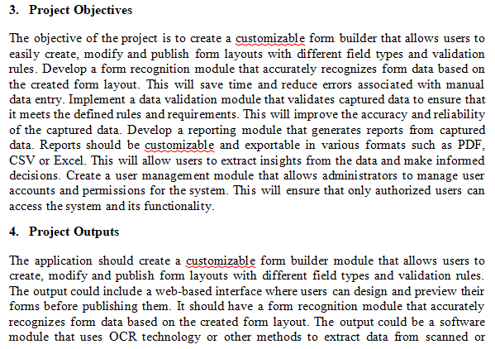

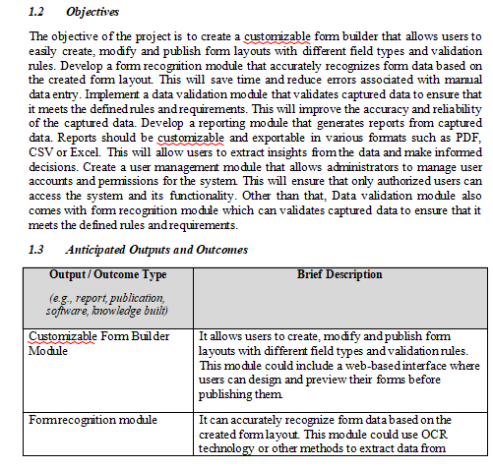

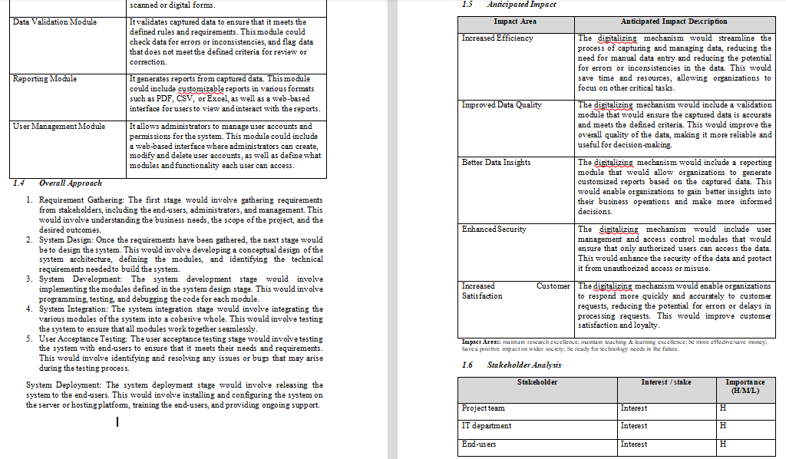

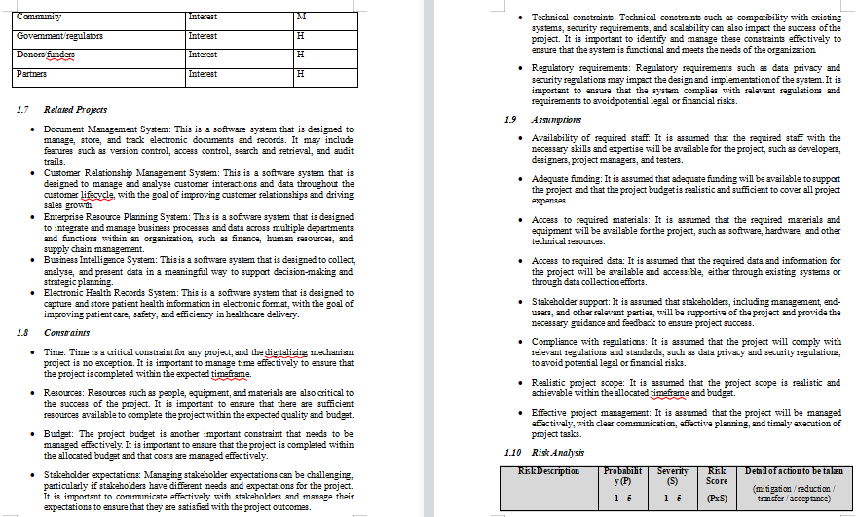

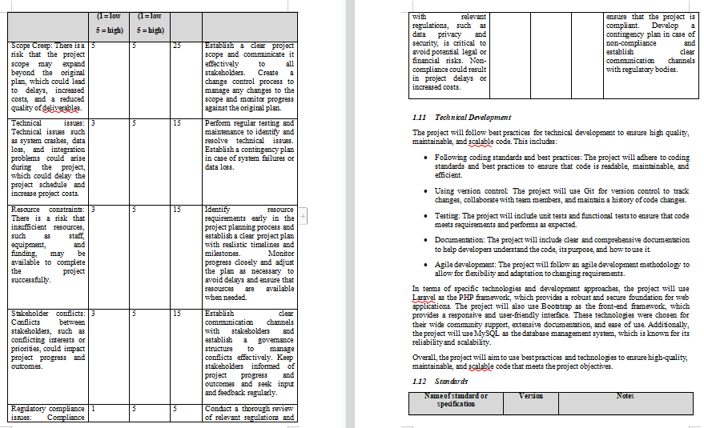

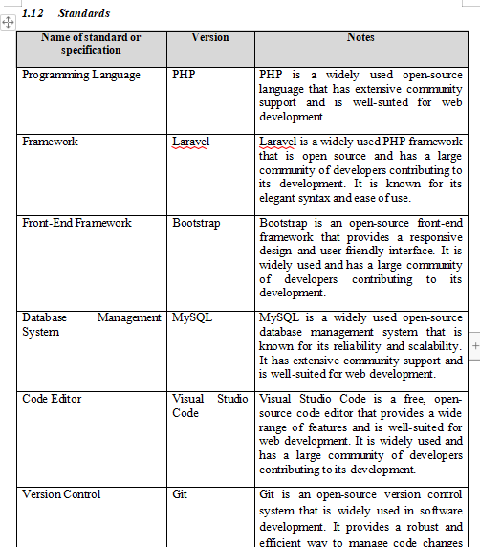

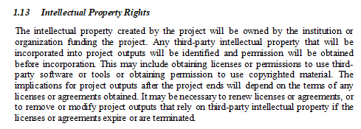

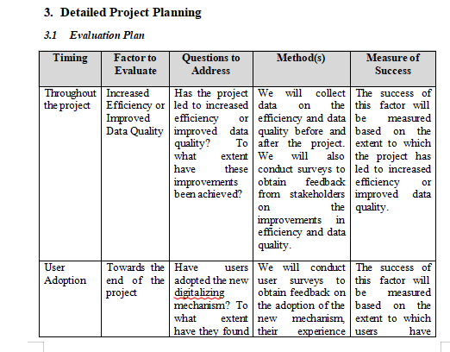

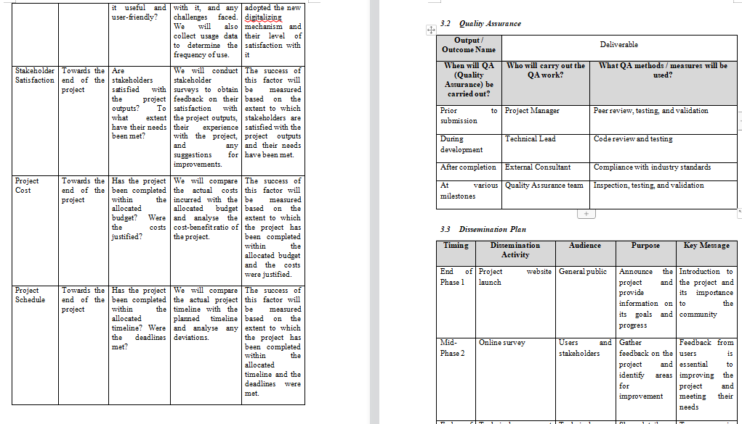

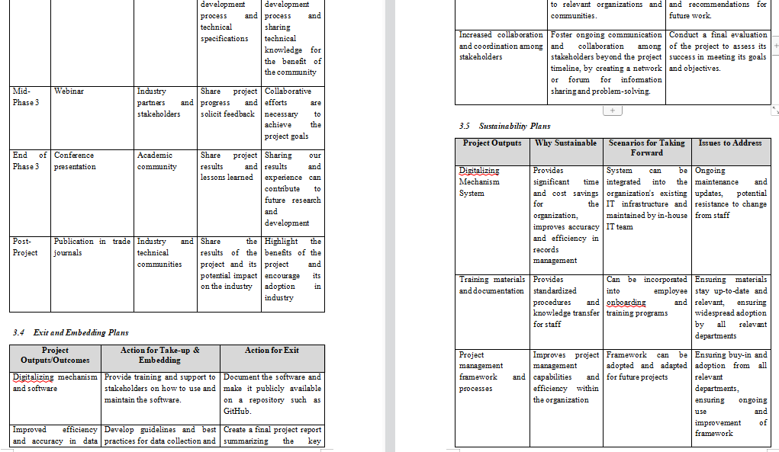

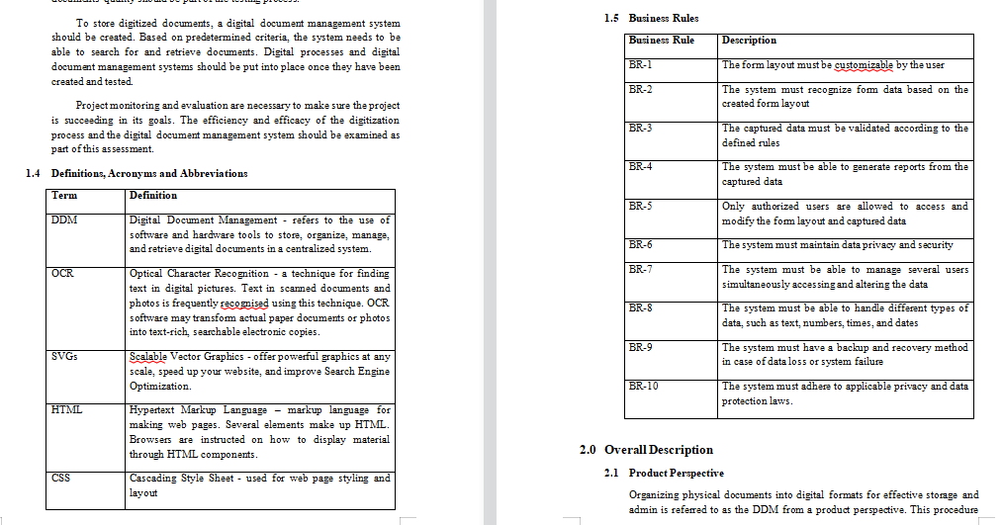

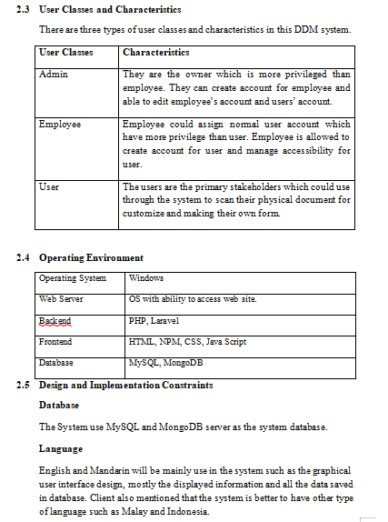

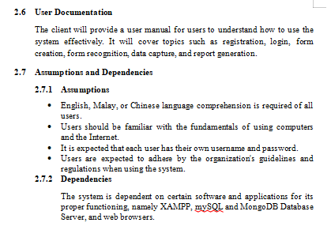

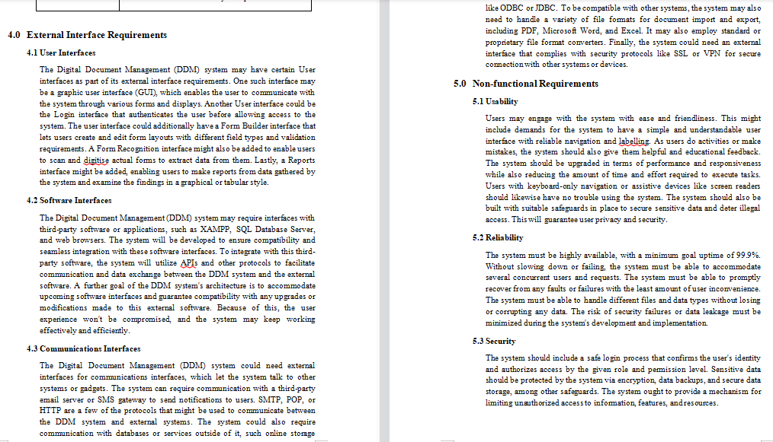

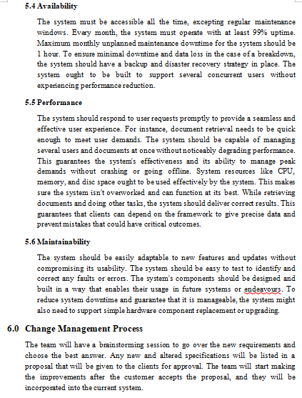

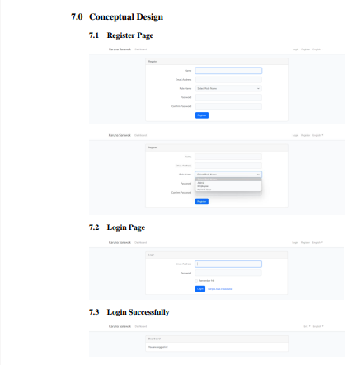

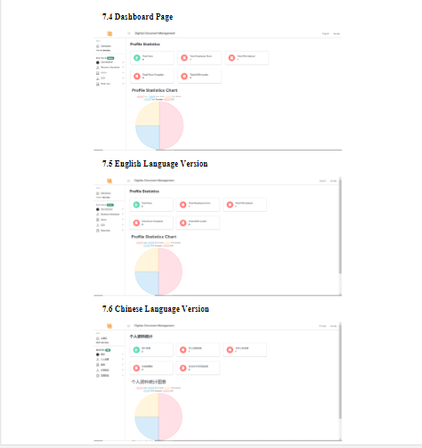

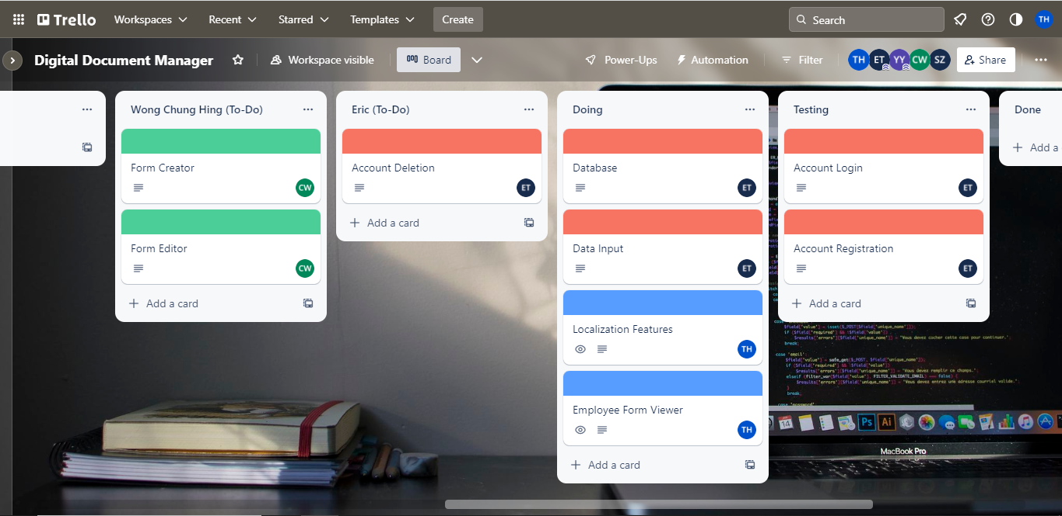

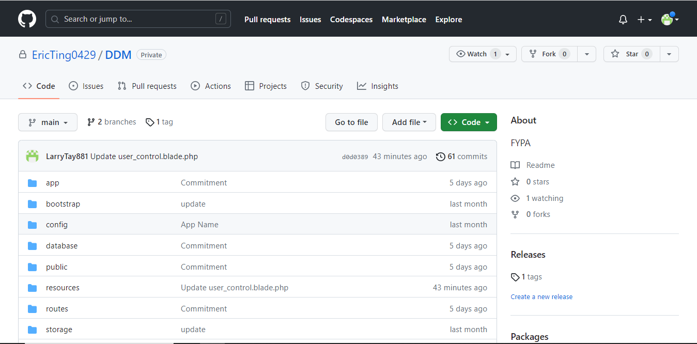

|  |  |  |  |
| --- | --- | --- | --- |
| Demonstration | Description | Estimated % of the total assignment | Which section of SQAP does each address? |
| Project Proposal | A detailed description of the purpose of the project and what the team plans to achieve by the end of the project | 5 | Research and Analysis |
| Project Plan | Detailed description the series of tasks and milestones required to successfully develop, test, and deploy the proposed document digitization system. | 5 | Research and Analysis |
| SRS | Detailed description the requirements and specifications for a software project, including functional and non-functional requirements, system architecture, user interface design, and other relevant details. | 5 | Analysis |
| SDD | A Software Design Document (SDD) is a comprehensive guide that outlines the architecture, design, and specifications of a software system. | 5 | Analysis |
| Login web page | The login web page serves as the entry point for registered users. It typically includes fields for users to input their credentials, such as email or username and password. | 1 | Design and Product |
| Register Account web page | The register account web page allows new users to create an account. It usually includes fields for personal information, email,select a user role, password, and may implement security features like a strong password policy. | 2 | Design and Product |
| Reset Account Password by sent Reset Link to Email | A functionality enables users who have forgotten their passwords to request a password reset link that is sent to their registered email address. | 1 | Design and Product |
| Dashboard | A visual representation of key information, data, and metrics that provides users with a quick and concise overview of the status, performance, and trends of a system, process, or business. It typically presents data in the form of charts, graphs, tables, and other visual elements to facilitate easy comprehension and analysis. | 1 | Design and Product |
| User Management Module | A component of a software application that handles the management and administration of user accounts and permissions. It provides functionality to create, update, and delete user accounts, as well as manage user roles and access rights within the system. | 3 | Design and Product |
| Employee Form | A document used to collect and record important information about an employee within an organization. It serves as a standardized template to gather and maintain essential details related to an employee's personal. | 2 | Design and Product |
| User Feedback Module | A module able Admin to view feedback provided, report issues and improvement suggestion from users. | 2 | Design and Product |
| Personal Information | A module able user to edit their information such as user name, email address and avatar. | 1 | Design and Product |
| Employee Form Viewer | A module that allows authorized users to view and access employee forms and their associated information in a digital format. It provides a user-friendly interface for efficiently browsing, searching, and reviewing employee forms and data. | 2 | Design and Product |
| Report Form Upload File Viewer | A module that allows authorized users to view and access forms uploaded in a digital format. It provides a user-friendly interface for efficiently browsing, searching, and reviewing uploaded forms and data. | 2 | Design and Product |
| Change Password Feature | A functionality provided within a system that allows users to modify their existing password and set a new password for their account. | 1 | Design and Product |
| Localization Module | A language switcher is a user interface element that allows users to switch between different languages in a software application or website, enabling the localization of content to meet the needs of a global audience. | 4 | Design and Product |
| Report Generator Module | A module provide option for exporting reports in various formats, such as PDF and Excel | 5 | Design and Product |
| Strong Password Policy | A strong password policy is critical to protecting user accounts from unauthorized access, data breaches, and other security threats. | 1 | Product |
| Feedback Form module | A module able users to provide feedback, report issues and provide feedback to administrator | 2 | Design and Product |
| Role Based Access Control | A feature adds restrictions to the system by adding an additional layer of control, allowing only two Administrator role users in the system. | 5 | Product |
| Account Management | A function involves managing user accounts, permissions, and access within a system or organization. It ensures security, tracks user activities, and maintains a well-organized user database. | 5 | Product |

|  |  |  |  |
| --- | --- | --- | --- |
| Demonstration | deadline as set in meeting | Date started | Date Completed |
| Project Proposal | 13 March 2023 | 8 March 2023 | 11 March 2023 |
| Project Plan | 13 March 2023 | 8 March 2023 | 11 March 2023 |
| SRS | 20 March 2023 | 14 March 2023 | 19 March 2023 |
| Localization Module | 25 May 2023 | 28 March 2023 | 16 May 2023 |
| Dashboard | 25 May 2023 | 19 April 2023 | 16 May 2023 |
| User Management Module | 25 May 2023 | 28 April 2023 | 8 May 2023 |
| Employee Form | 25 May 2023 | 19 April 2023 | 24 April 2023 |
| Employee Form Viewer | 25 May 2023 | 19 April 2023 | 24 April 2023 |
| Change Password Feature | 25 May 2023 | 28 April 2023 | 1 May 2023 |
| Send Password Reset Link to Email | 15 October 2023 | 11 September 2023 | 18 September 2023 |
| Feature Restrict Number of Admin User | 15 October 2023 | 21 September 2023 | 28 September 2023 |
| Report Generator Module in PDF Format | 15 October 2023 | 1 October 2023 | 4 October 2023 |
| Update Dashboard Feature | 15 October 2023 | 5 October 2023 | 9 October 2023 |
| Edit Profile module | 15 October 2023 | 11 October 2023 | 11 October 2023 |
| Strong Password Policy function | 25 November 2023 | 12 October 2023 | 15 October 2023 |
| User Feedback Module | 25 November 2023 | 20 October 2023 | 30 October 2023 |
| Report Generator Module in Excel Format | 25 November 2023 | 2 November 2023 | 20 November 2023 |

* 1. **Involvement**

*[P] “Acceptable level of attendance and engagement with respect to both internal (team) and external (client) related activities.”*

*[C] “An active level of engagement (internal and external), including organisation and leadership responsibilities.”*

*[D] “An active level of contribution across multiple areas or responsibilities of the project, including significant input to important decisions (documented).”*

*[HD] “Active leadership/ownership of key responsibilities resulting in high quality outcomes for the project. Key indicators of this would include personal contribution across multiple areas of the project, as well as providing support and leadership to members of the team.”*

|  |  |  |  |
| --- | --- | --- | --- |
| Activities | Description | Type  (Internal/External) | What is your role in the activity? |
| Project Proposal Discussion with the team | Evaluate the project's goal, then have a detailed discussion with the team. | Internal | Contributer |
| Project Plan Discussion  with the team | Evaluate the project's goal, then have a detailed discussion with the team. | Internal | Contributer |
| SRS Discussion  with the team | Asking detailed questions regarding the features and workload distribution | Internal | Contributer |
| SRS Discussion  with the client | Going through the design process and conceptual design with the client, and ensuring that everything satisfies them | Internal | Contributer |
| Software Design Document with the team | Evaluate the project's design, then have a detailed discussion with the team. | Internal | Contributer |
| Record meeting video | Record the video that is presented during the team meetings and client meetings. | Internal | Chair / Lead /  Contributor |
| Meeting with client | Listening to the clients' opinions and thoughts, especially project-related topics | Internal | Contributer |
| System Development | Writing code, building and integrating components, testing, debugging, and ensuring that the software functions as per the project requirements and design specifications. | Internal | Contributer |

|  |  |  |  |
| --- | --- | --- | --- |
| Activities | Role (Chair/Lead/Contributor) | Type  (Internal/External) | What was your contribution? |
| Project Proposal report | Contributer | Internal | I done 15% of contribution in the report |
| Project Plan report | Contributer | Internal | I done at least 20% above of contribution in the report |
| System Requirement Specification report | Contributer | Internal | I done at least 20% above of contribution in the report |
| Record meeting video | Chair / Lead /  Contributor | Internal | I am responsible for recording all the team meetings and client meeting videos. |
| System Development | Contributer | Internal | I contributed at least 30% in the team |

Total and summarise your involvement in the table below

|  |  |
| --- | --- |
| Total number of presentation feedback provided | 4 |
| Total number of activities | 8 |
| Total number of internal and external related activities | 8 |
| Percentage of contribution | 40% |

**Table of my own contribution in Team**

|  |  |
| --- | --- |
| Item | Total Percentage I done |
| Project Plan | 15% |
| Project Proposal | 20% |
| SRS | 20% |
| SDD | 15% |
| Client Meeting | 20% |
| Team Meeting | 20% |
| Presentation | 10% |
| Meeting Minutes Document | 15% |
| Login web page | 100% |
| Register Account web page | 100% |
| Reset Account Password by sent Reset Link to Email | 100% |
| Dashboard | 100% |
| User Management Module | 90% |
| Employee Form | 100% |
| User Feedback Module | 100% |
| Personal Information | 80% |
| Employee Form Viewer | 100% |
| Report Form Upload File Viewer | 100% |
| Change Password Feature | 100% |
| Localization Module | 70% |
| Report Generator Module | 100% |
| Strong Password Policy | 100% |
| Feedback Form module | 100% |
| Role Based Access Control | 80% |
| Account Management | 100% |

## Reflection

### The most important things I leant:

*The team and I communicated clearly and productively with one another throughout the course of these six weeks. Even if there were instances of miscommunication or misunderstanding, the team management talked things over and reached a consensus. Also, I became aware of the value of recording meeting minutes. The team's ability to envisage a clear target was aided by the existence of paperwork, which also served to establish agreements, permission, and expectations of the decisions taken, keeping everyone on the same page.*

### The things that helped me most were:

Google search and ChatGPT played a big part in assisting me whenever I had problems. I could search and find most of the coding-related issues on Google and even learned about new programming frameworks.

### I found the following topics particularly challenging:

The project as a whole was challenging for me since I had to learn a new programming framework while also trying not to bother them with my issues with other subjects.

### I found the following topics particularly interesting:

### I feel I learnt these topics, concepts, and/or tools really well:

The tool that I have learned particularly well was the Laravel PHP framework. Laravel is an open-source PHP framework, a component-based PHP framework that is used to rapidly develop web applications. I learned how the PHP functions run with different frameworks and how to query data when implementing the APIs. Laravel PHP was introduced to me when the client suggested our team was deciding which development tool to utilize. I was able to adapt to Laravel as I know JavaScript, HTML, PHP, and CSS.

### I still need to work on the following areas:

*I believe the areas that I need improvement on are expressing more of my personal opinion during meetings and discussions. I also did not speak a lot of my views because I was too shy to say anything.*

### My progress in this unit was …:

*My progress in this unit with the team was relatively well. I was satisfied with what the team had done, as everything the team planned was completed on time.*

### This unit will help me in the future:

*This unit helped me experience and understand what an actual industrial project would be like. It also gave me the experience of completing a project with a team with realistic and achievable expectations. With this experience, I believe I would be confident and prepared for future development projects*

### If I did this unit again I would do the following things differently:

*If I retake this unit again, I will attempt to speak out more during meetings and conversations and volunteer for more tasks. The rest of the time, I would go in the same order the team, and I did, and it worked out very nicely.*

### Other…:

## Conclusion

In summary, I believe that I have clearly demonstrated that my outcomes are sufficient to be awarded a Pass grade.